

**Newsletter - 21 December 2018**

**Our Catholic Mission**

Thank you to Fr Anthony and all family, parishioners and visitors who came into school to celebrate Mass today.

Children are welcome to attend the vigil mass on Christmas Eve dressed in nativity clothes (if they wish).

**Parish Mass/Children’s Liturgy**

The parish newsletter or website [www.romancatholiclichfield.co.uk](http://www.romancatholiclichfield.co.uk) contains information about Masses and other church notices.

Mass Times: 6pm Saturday @ SS Peter & Paul

(with Children’s Liturgy)

8.30am Sunday @ Holy Cross   
(with Children’s Liturgy)

11am Sunday @ SS Peter & Paul  
(with Children’s Liturgy)

**Attendance**

Congratulations to Y4 the class with the highest attendance of 97.1% this week.

**Thanks from the staff**

We would like to thank you for your Christmas wishes, presents and cards - your generosity and kindness is appreciated.

**School Swimming – Y3**

School swimming lessons start again on Monday 7 January 2019.

**After School Clubs**

Please see the school website for After School Club information and how to join.

Start back dates have been added to the website.

Mrs Credali has spaces in her clubs and is happy for children to have a taster session.

**Waitrose Fundraiser**

Our fantastic PTFA have been accepted as a local fundraiser at Waitrose. If you or anyone you know are shopping could you please put your green token in our box?

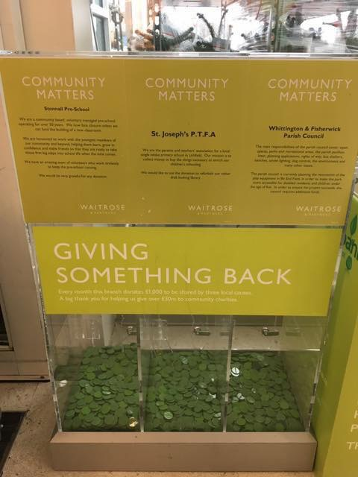

**Pre-School**

* We are delighted to welcome Mrs Whitehouse to the Pre School team.
* Please remember to send the children with warm appropriate clothing as we are outside whatever the weather!

**Reception Class Admissions - September 2019 – Please take action NOW!**

On-line applications for primary school has now opened. The closing date for applications is 15 January 2019. The best way to apply is online at [www.staffordshire.gov.uk/admissions](http://www.staffordshire.gov.uk/admissions)If your child's 5th birthday is between 1 September 2019 and 31 August 2020 then you will need to apply for a place at First, Infant or Primary School.

**Snacks**

From 7th January you will need to pre-book your child’s break-time snack (can be done up to 8am on the day required inc cancellations) using ParentPay.   
Please see the school website for further information.

**End of Term reports**

You should have received your end of term report for children from Year 1 up to Year 6 this week. This is a new initiative aiming to keep you more regularly informed about your child’s attainment and progress. Thank you to a small number of parents for their positive comments about the report. If you have any feedback about the report that you would like to share, please email the office.

**School Crossing Patrol**

We have been contacted by Councillor Helen Fisher regarding the proposed removal of School Crossing Patrol Services. As you will be aware this is a service that is greatly needed on our busy road. Unfortunately this is not a cost that could be met from our already stretched school budget. Staffordshire County Council are looking for parent input on how the costs could be met. Please visit <https://www.staffordshire.gov.uk/education/schoolsandcolleges/SchoolCrossing/SchoolCrossingPatrols.aspx> to share your views - closes 31st December 2018.

**PTFA News**

Please see the school website and calendar for more information.

A huge thanks to the PTFA Team and everyone who helped to make the Christmas Fayre a huge success – an amazing **£1857** was raised! What a fantastic achievement that all our children will benefit from. Thank you again!

***And Finally…***

As always, it was lovely to welcome so many families and friends to our Christmas Plays this week. A big thank you to the PTFA for providing refreshments, however a special thank you must go to Pre-School, Reception, Y1 and Y2 for their delightful and magical Nativity plays.

The KS2 Carol Service was a wonderful, atmospheric celebration of the Christmas Story.  The children were fantastic and so many people, including parishioners, have commented positively.  We would also like to thank the teachers for their hard work and commitment and also a big thanks to Miss Cooper for playing on the night! We are very proud of the effort that the children made and I cannot tell you how proud I was of each and every one of them.

If any parent or grandparent has a few spare minutes and would like to comment on any of the plays or Carol service, please drop us a letter or email. We keep this feedback as evidence of the Catholic life of the school. Many thanks.

May I wish you and your families, wherever you will be, a happy and holy Christmas.

May God be with you

Mrs D McLeary

Headteacher

Today a saviour has been born to us.

He is Christ the Lord

